THRIVE WEEK MEDIA GUIDE
WHAT IS THRIVE WEEK?
Thrive Week is a week-long series of events aimed towards helping McMaster students, faculty, and staff explore their pathways to mental health.
Thrive is also a mindset. We all have mental health, and we can each strengthen our mental health by learning about it, thinking about it, talking about it, and discovering new skills and resources to help us! McMaster is committed to enhancing mental health and well-being for all of our community members by supporting healthy and sustainable workplaces and learning environments.
Although this is McMaster’s first Thrive Week, the Thrive initiative is not new. Schools across Canada have been hosting annual Thrive Weeks as a means of educating, promoting, and advocating for student mental health on campus. Thrive began in 2009 as an idea between colleagues at the University of British Columbia.
For all Thrive updates, schedule for the week, and more, visit: wellness.mcmaster.ca/thriveweek
GENERAL MESSAGING
Please consider tagging McMaster Student Wellness Centre in your post; we are @McMasterSWC on all platforms (Facebook, Instagram, and Twitter).
- The journey of mental health is different for everybody, discover your path during Thrive Week 2019
- Thrive (not just survive) all year long with strategies, skills, and resources to help you prosper and flourish
- Make small decisions each day that bring you closer to positive mental health, attend an event this Thrive Week!
- As a community, together we can thrive by learning, thinking, and talking about mental health.

THRIVE WEEK CHECKLIST
ONE MONTH BEFORE THRIVE (early January)
- Your department’s Facebook page will be added a co-host to the respective Facebook event
- Introduce your audience(s) to Thrive Week, invite them to attend events and encourage them to think about what thriving means to them
  - Introduce your own events and workshops
- Follow @McMasterSWC on Facebook, Twitter and Instagram to like, share and comment on Thrive posts
  - Share the promotional video
ONE WEEK BEFORE THRIVE (late January)
- Check the Thrive events calendar for events that are relevant to your audience, you can promote them on social media, send in emails, or print them
- Promote your own events again
DURING THRIVE (Feb 4 – Feb 8, 2019)
- Share photos and videos of your events and the week on your channels using #StayWellMac
  - Tag @McMasterSWC to be re-storied and reposted on SWC channels
- Challenge yourself along with a friend or colleague to attend a Thrive event during the week

IMAGE FOR SOCIAL MEDIA
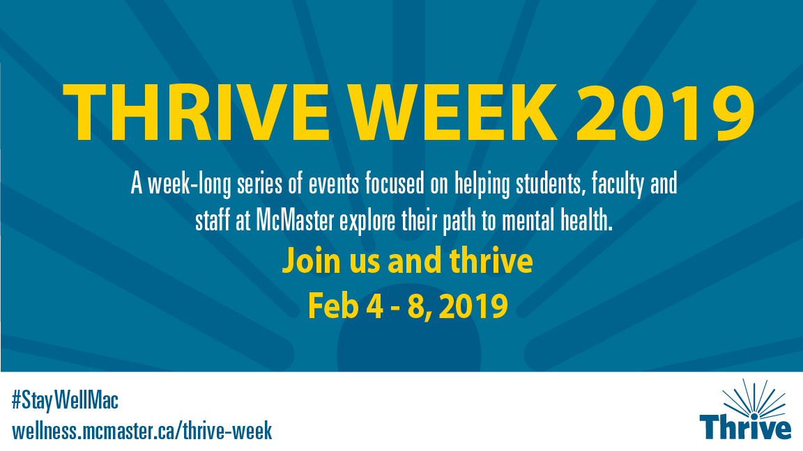
TEMPLATE DESIGNS
Powerpoint Templates (Presentation Object -> Edit/Open)
4 x 3 -
16 x 9 -
Poster Templates:
11 x 17 – PDF
Legal – PDF

